CSIT314 Software Development Methodologies - Group Project

Sprint 1 - US3: Create user profile
Interior Design Platform - User Admin
All diagrams were drawn in draw.io. Open "US3 Create user profile.drawio" in this folder to edit them - each diagram is its own page in that file. The exported images are in the "diagrams" folder.

Assumptions
- The system is the Interior Design Platform from the project specification. Sprint 1 covers the User Admin's log in / log out and managing user profiles and user accounts (US1-US12).
- A user profile is a user group, e.g. User Admin, Interior Designer, Customer or Platform Manager. It has a name, a description, a list of permissions (what its users can do) and a status (Active or Suspended). Every user account belongs to exactly one user profile and gets that profile's permissions.
- We follow B-C-E: the actor only talks to the boundary (page), the boundary only talks to the controller, and the controller works with the entity classes. There is one controller per use case.
- The boundary checks all the input (required fields, lengths, formats, e.g. not suspending your own profile) and trims spaces, then passes an entity object on. The controller just calls the entity and returns the result. The entity checks for duplicates and the database state (e.g. name already used, only Active rows are changed), then saves.
- Being logged in as a User Admin is a precondition (UC1), so this use case never checks it again. loginRequired in app.py only sends someone with no session to /login.
- The platform has a fixed list of permissions: Manage user accounts, Manage user profiles, Manage company profile, Manage own IDPs, View IDP statistics, Search, view and save IDPs, Manage IDP categories, Generate reports. The User Admin picks from this list - they can't type new permissions.
- A profile name must be 3-50 characters and must be different from every other profile name (capitals don't matter, so "customer" counts as "Customer"). The description is optional.
- A new profile always starts with status Active.
- The page trims the input and builds a UserProfile object (profile = UserProfile(profileName, description, permissions)). That object is passed to validateInput(), the controller and the entity - not loose fields.

1. User story
Story ID | US3
User story | As a user admin, I want to create a user profile so that I can set up a user group and choose what its users can do.
Actor | User Admin
Priority | High
Story points (estimate) | 5
Acceptance criteria | 1. Given I am on the User Profiles page, when I click "Create user profile", then I see a form with Profile name, Description and a list of all the permissions as tick boxes.  2. Given I fill in a new name (3-50 characters) and tick at least one permission, when I click "Create", then the profile is saved with status Active, I see "User profile created successfully" and it shows up in the list.  3. Given the name is empty, shorter than 3 or longer than 50 characters, or no permission is ticked, when I click "Create", then nothing is saved and the problem fields are highlighted with a message.  4. Given another profile already has that name (any capitals), when I click "Create", then nothing is saved and I see "A user profile with this name already exists".  5. Given I click "Cancel", then nothing is saved and I go back to the list.
Tasks | #61 Draw Create User Profile Use Case Diagram  #62 Write Create User Profile Use Case Description  #63 Draw Create User Profile BCE Diagram  #64 Draw Create User Profile Sequence Diagram  #65 Design Create User Profile Wireframe  #66 Write and Execute Create User Profile Test Cases

2. Use case diagram
The user story becomes one use case, UC3 Create user profile. The User Admin is the only actor.
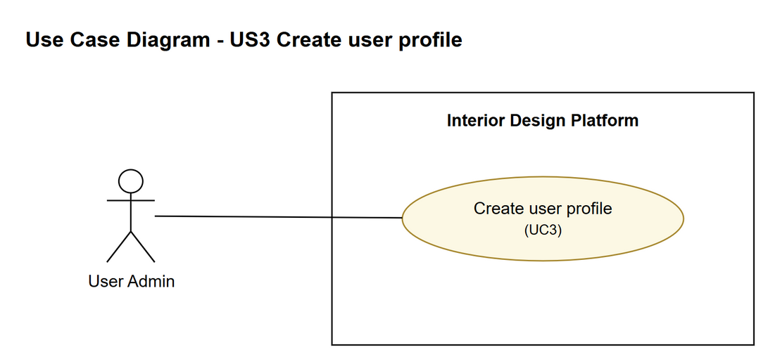
Figure 1: Use case diagram for US3 Create user profile

3. Use case description
Use case | UC3 Create user profile
Actor | User Admin
Brief description | The User Admin sets up a new user group by giving it a name and description and choosing what its users are allowed to do.
User story | US3: As a user admin, I want to create a user profile so that I can set up a user group and choose what its users can do.
Preconditions | The User Admin is logged in (UC1).  The User Admin is on the User Profiles page.
Trigger | The User Admin clicks "Create user profile".
Basic flow | 1. The User Admin clicks "Create user profile".  2. The system gets the list of permissions and shows the create user profile form.  3. The User Admin enters a profile name and a description, ticks the permissions the group should have and clicks "Create".  4. The system trims the spaces and checks that the name is 3-50 characters and at least one permission is ticked.  5. The system checks that no other user profile has the same name (capitals don't matter).  6. The system saves the new user profile with status "Active".  7. The system shows "User profile created successfully" and the new profile in the list.
Alternative flows | 3a. The User Admin clicks "Cancel": nothing is saved and the list is shown again. The use case ends.  4a. The name is missing or the wrong length, or no permission is ticked: the system highlights the fields with a message and keeps what was typed (back to step 3).  5a. Another profile already has this name: the system shows "A user profile with this name already exists" (back to step 3).
Postconditions | A new Active user profile with the chosen permissions is saved.  It can now be given to user accounts.

4. Wireframes
The wireframes were drawn in draw.io. They are low-fidelity: they show the layout and the flow, not the final colours. The orange numbers match the notes under each screen.

4a - User Profiles page
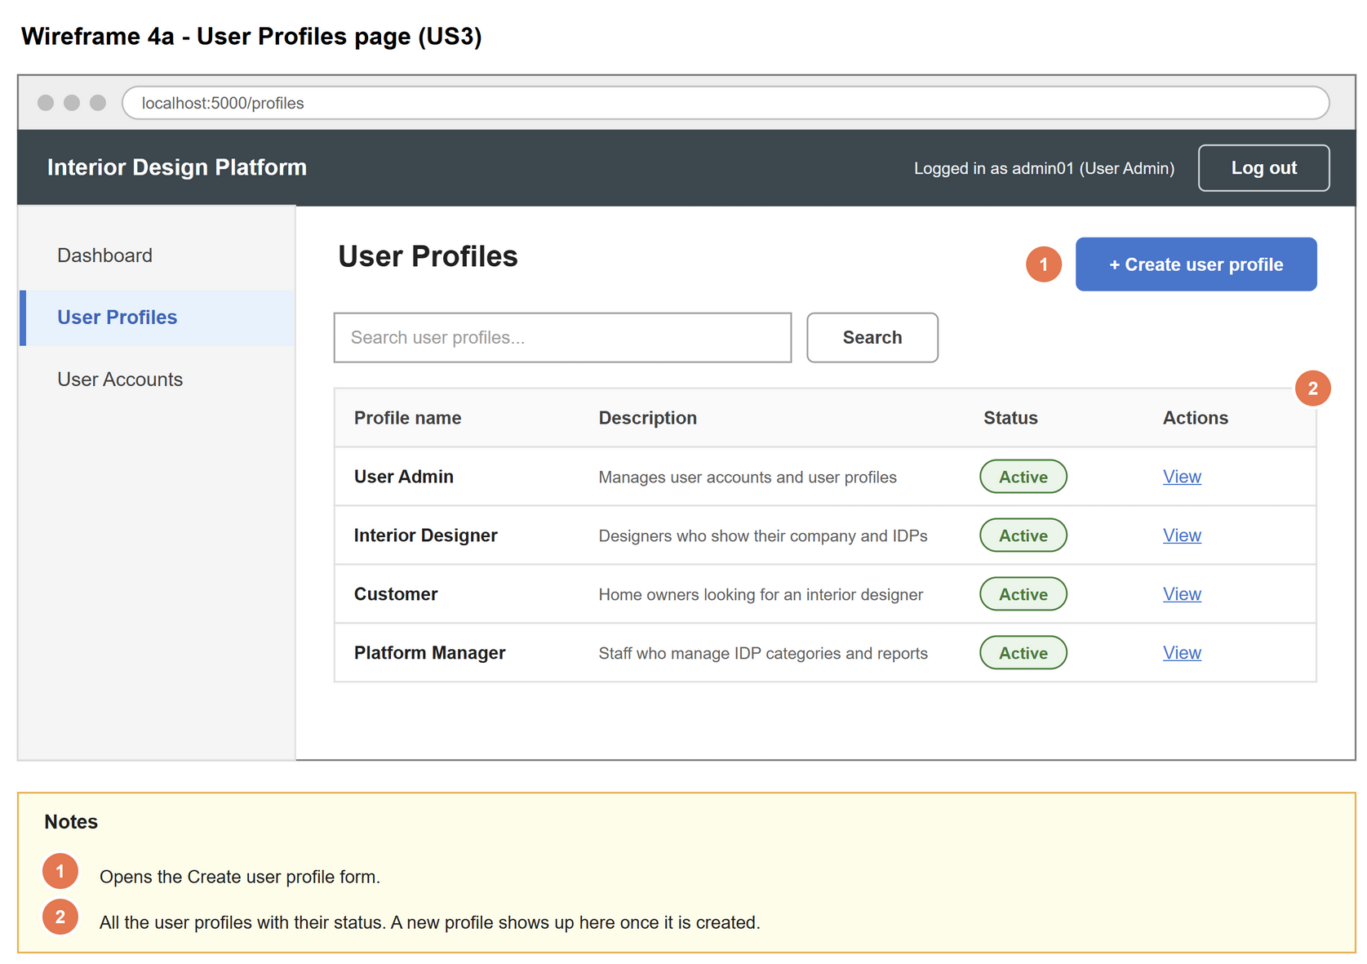
Figure 2: Wireframe 4a - User Profiles page (US3)

4b - Create user profile form
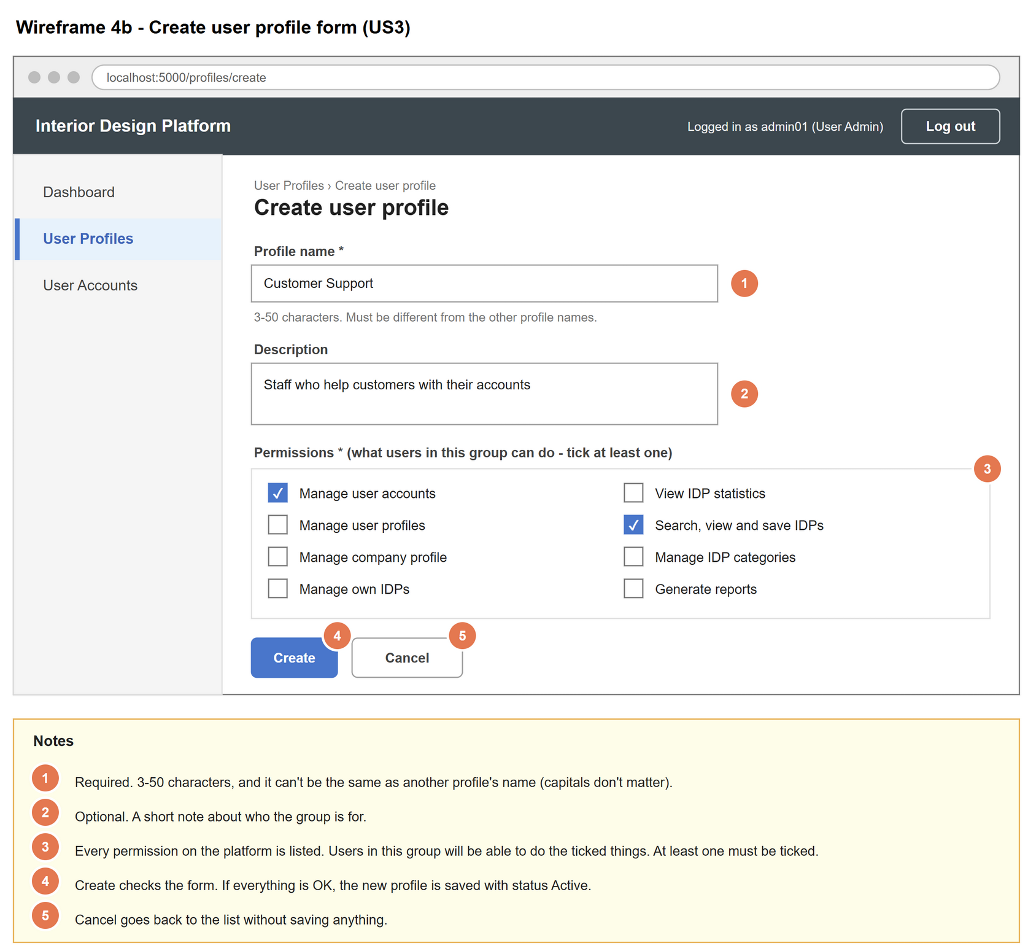
Figure 3: Wireframe 4b - Create user profile form (US3)

4c - Create form with errors
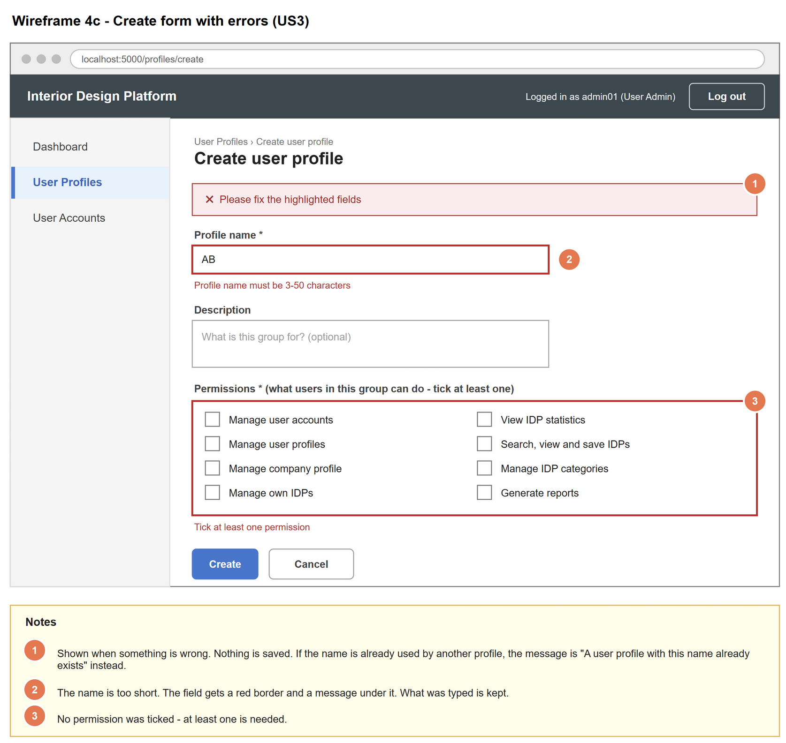
Figure 4: Wireframe 4c - Create form with errors (US3)

4d - User profile created
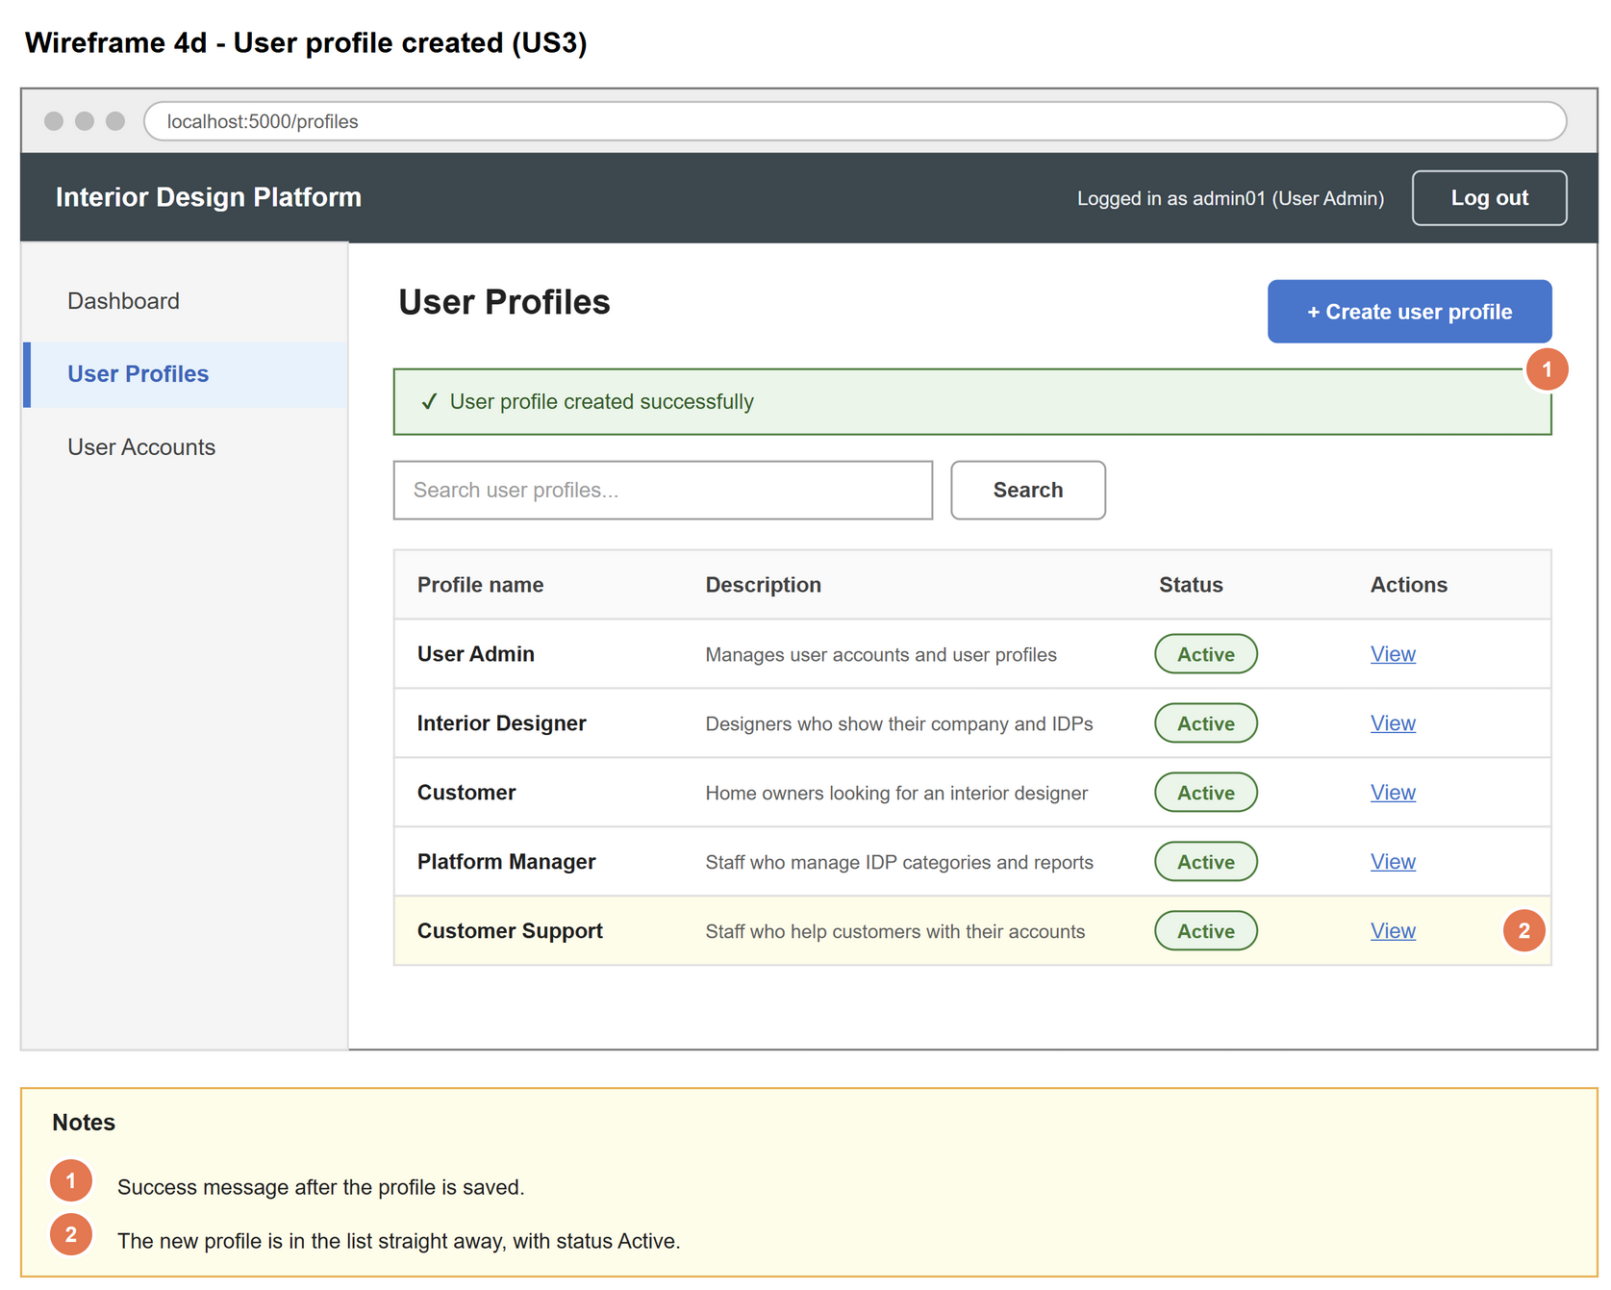
Figure 5: Wireframe 4d - User profile created (US3)

5. B-C-E class diagram
The solid arrow means the boundary calls the controller. The dashed arrows mean the controller uses the entity class. Only the operations needed for this use case are shown.
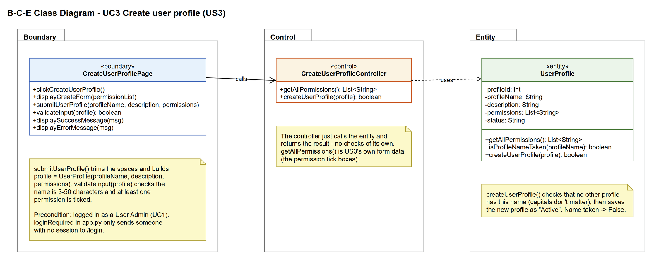
Figure 6: B-C-E class diagram for US3 Create user profile
Layer | Class | What it does
Boundary | CreateUserProfilePage | The create user profile form. Shows the permission tick boxes, trims the input, builds a UserProfile object, checks the name length and that a permission is ticked (validateInput(profile)), and shows the success or error message.
Control | CreateUserProfileController | Controller for UC3. getAllPermissions() gets the permission list for the form, and createUserProfile(profile) passes the profile to UserProfile and returns the result. It has no checks of its own.
Entity | UserProfile | The user group. Knows the list of permissions. createUserProfile(profile) checks that the name isn't already used (isProfileNameTaken(), capitals don't matter), then saves the new profile with status Active.

6. Sequence diagram
Messages 1-6 are steps 1-2 of UC3: the form is loaded with the permission list from UserProfile. Cancel is a plain link back to the list, so it is only a note (alternative flow 3a). After the User Admin submits the form, the page trims the input, builds a UserProfile object and checks it (messages 8-9). The outer alt splits on that check (alternative flow 4a). If the input is fine, the page passes the profile to the controller, which just calls UserProfile.createUserProfile(profile). The entity checks that the name is not taken (step 5) and only then saves the profile (opt box, step 6). The inner alt shows the success message (step 7) or the "name already exists" message (alternative flow 5a).
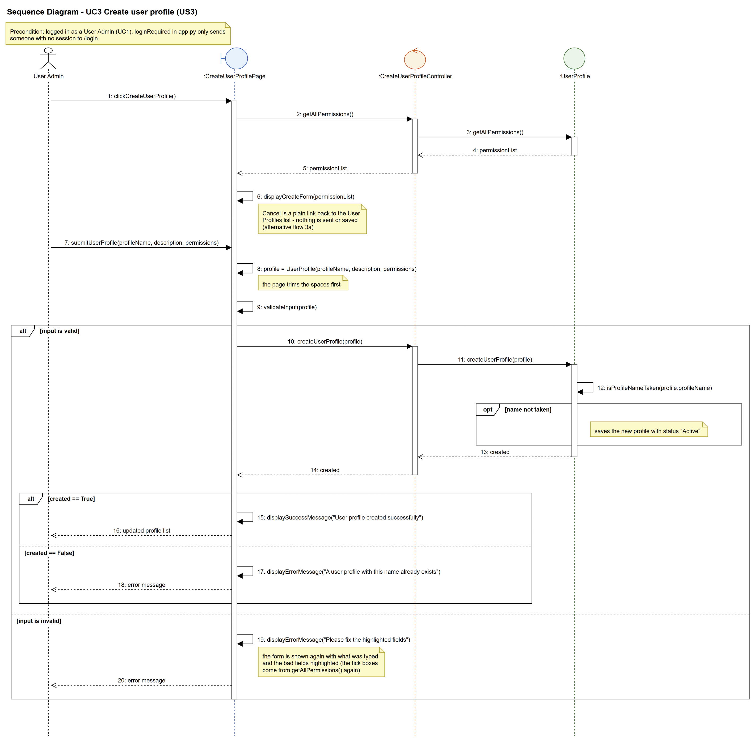
Figure 7: Sequence diagram for UC3 Create user profile

7. Test cases
Test data used below: user profiles User Admin (id 1), Interior Designer (id 2), Customer (id 3) and Platform Manager (id 4), all Active. User accounts admin01 / Admin@123 (User Admin, Active), admin02 / Admin@123 (User Admin, Suspended), designer1 / Pass@123 (Interior Designer, Active) and cust001 / Cust@123 (Customer, Active).

7a. System test cases (black box)
Equivalence partitioning and boundary value analysis were used to pick the test data. Fill in "Actual result" and "Pass/Fail" after running each test.
Test ID | Scenario | Prerequisites | Test steps | Test data | Expected result | Actual result | Pass / Fail
TC3.1 | Create a profile with valid details | Logged in as admin01. No profile called Customer Support. | 1. Go to User Profiles  2. Click "Create user profile"  3. Fill in the form  4. Click "Create" | Name: Customer Support  Description: Staff who help customers with their accounts  Permissions: Manage user accounts; Search, view and save IDPs | "User profile created successfully". Customer Support is in the list with status Active and the 2 permissions.
TC3.2 | Name left empty | Logged in as admin01. | Same as TC3.1 | Name: (empty)  Permissions: Generate reports | "Profile name must be 3-50 characters" under the name. Nothing saved. Ticked boxes kept.
TC3.3 | Name 2 characters (just under the minimum) | Logged in as admin01. | Same as TC3.1 | Name: AB  Permissions: Generate reports | Same error as TC3.2. Nothing saved.
TC3.4 | Name 3 characters (the minimum) | No profile called Ops. | Same as TC3.1 | Name: Ops  Permissions: Generate reports | Profile created with status Active.
TC3.5 | Name 50 characters (the maximum) | - | Same as TC3.1 | Name: "A" typed 50 times  Permissions: Generate reports | Profile created with status Active.
TC3.6 | Name 51 characters (just over the maximum) | - | Same as TC3.1 | Name: "B" typed 51 times  Permissions: Generate reports | Same error as TC3.2. Nothing saved.
TC3.7 | No permission ticked | - | Same as TC3.1 | Name: Guest  Permissions: (none) | "Tick at least one permission". Nothing saved.
TC3.8 | Name already used | The Customer profile exists. | Same as TC3.1 | Name: Customer  Permissions: Search, view and save IDPs | "A user profile with this name already exists". Nothing saved.
TC3.9 | Name already used, different capitals | The Customer profile exists. | Same as TC3.1 | Name: cUSTOMER  Permissions: Search, view and save IDPs | Same result as TC3.8.
TC3.10 | Description left empty | No profile called Guest. | Same as TC3.1 | Name: Guest  Description: (empty)  Permissions: Search, view and save IDPs | Profile created (the description is optional).
TC3.11 | Cancel | No profile called Visitor. | 1. Open the create form  2. Fill it in  3. Click "Cancel" | Name: Visitor | Back on the list. No Visitor profile was saved.

7b. Unit test cases (for TDD)
These are written before the code (test-driven development) and run with pytest (python -m pytest). They cover normal inputs, abnormal inputs and boundary values.
Test ID | Class and method | Input / setup | Expected output | Type | Pass / Fail
UT3.1 | UserProfile.getAllPermissions() | - | Returns the 8 permissions | Normal | Pass
UT3.2 | UserProfile.isProfileNameTaken() | "Customer" | Returns True | Normal | Pass
UT3.3 | UserProfile.isProfileNameTaken() | "cUSTOMER" | Returns True (capitals don't matter) | Abnormal | Pass
UT3.4 | UserProfile.isProfileNameTaken() | "Customer Support" | Returns False | Normal | Pass
UT3.5 | CreateUserProfileController.createUserProfile() | UserProfile("Customer Support", "Staff who help...", ["Manage user accounts"]) | Returns True. The saved profile has status "Active". | Normal | Pass
UT3.6 | CreateUserProfileController.createUserProfile() | UserProfile("Customer", "", ["Search, view and save IDPs"]) | Returns False. Number of profiles doesn't change. | Abnormal | Pass
UT3.7 | CreateUserProfilePage.submitUserProfile() (POST /profiles/create) | "", "", ["Manage user accounts"] | validateInput() returns False, so the controller is not called and nothing is saved | Abnormal | Pass
UT3.8 | CreateUserProfilePage.submitUserProfile() (POST /profiles/create) | "Guest", "", [ ] | validateInput() returns False, so nothing is saved | Abnormal | Pass
UT3.9 | CreateUserProfilePage.validateInput() | UserProfile("AB", "", ["Generate reports"]) | Returns False | Boundary | Pass
UT3.10 | CreateUserProfilePage.validateInput() | UserProfile("Ops", "", ["Generate reports"]) | Returns True | Boundary | Pass
UT3.11 | CreateUserProfilePage.validateInput() | UserProfile with a 50-character name, ["Generate reports"] | Returns True | Boundary | Pass
UT3.12 | CreateUserProfilePage.validateInput() | UserProfile with a 51-character name, ["Generate reports"] | Returns False | Boundary | Pass
UT3.12b | CreateUserProfilePage.validateInput() | UserProfile("Guest", "", [ ]) | Returns False and fieldErrors has an entry for "permissions" (so that field is highlighted) | Abnormal | Pass
UT3.12c | CreateUserProfilePage.submitUserProfile() (POST /profiles/create) | " Guest ", " hi ", ["Generate reports"] | The spaces are trimmed: a profile called "Guest" is saved with status "Active" | Boundary | Pass
UT3.13 | CreateUserProfilePage.submitUserProfile() (POST /profiles/create) | "Guest", "", ["Search, view and save IDPs"] | Back on the User Profiles list with "User profile created successfully". Guest is in the list. | Normal | Pass
UT3.14 | CreateUserProfilePage.submitUserProfile() (POST /profiles/create) | "cUSTOMER", "typed this already", ["Search, view and save IDPs"] | "A user profile with this name already exists" is shown and the form still has "typed this already" | Abnormal | Pass
UT3.15 | CreateUserProfilePage (GET and POST /profiles/create) | Logged in as admin01. Open the form, then submit "Customer", "", ["Search, view and save IDPs"] | The header still shows "Logged in as admin01 (User Admin)" on the form and after the error | Normal | Pass

